**B1:**

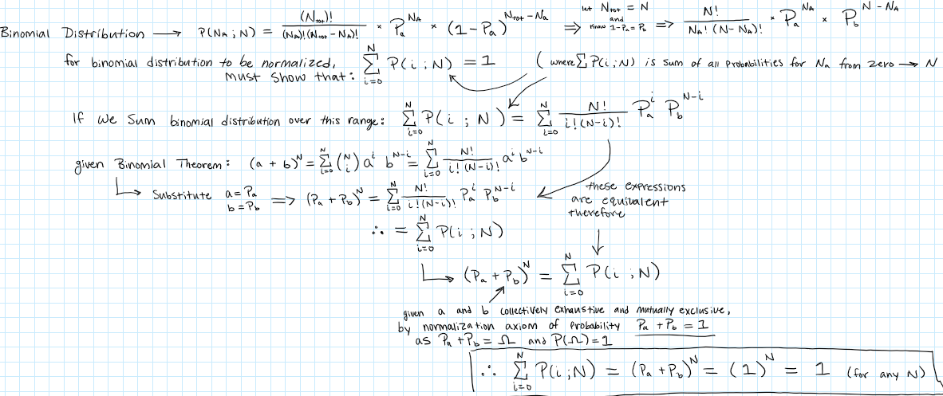

**B2:**

* See Jupyter notebook for solution.

**B3:**

* See Jupyter notebook for solution.

**B4:**

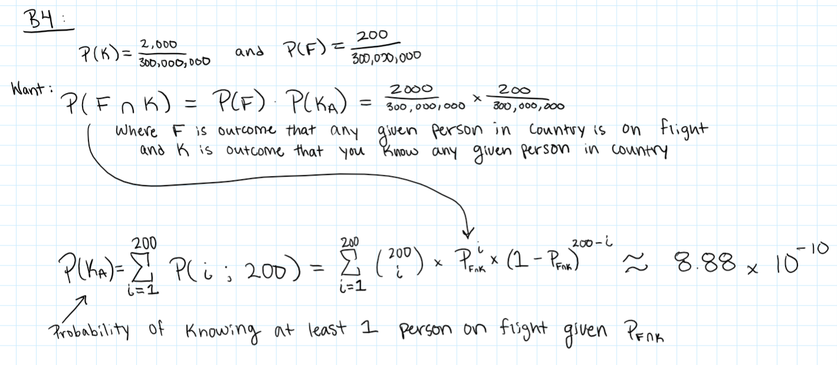

* + See Jupyter notebook for confirmation of solution.

**C1:**

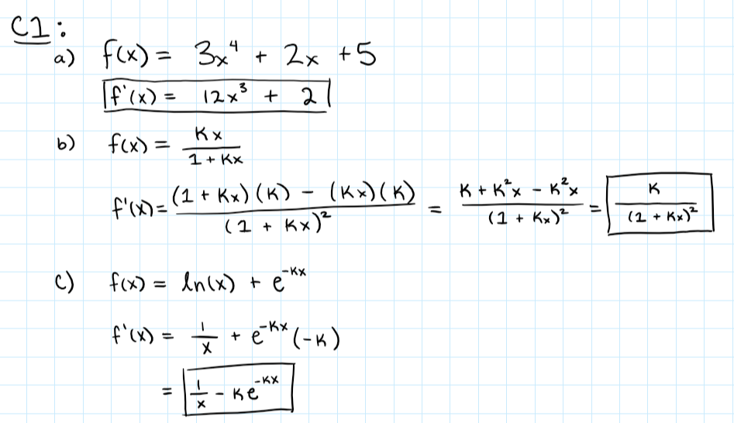

**C2:**

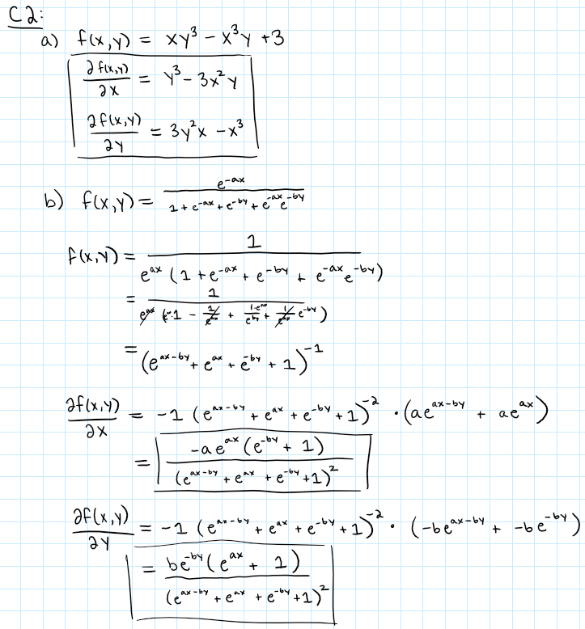

**C3:**

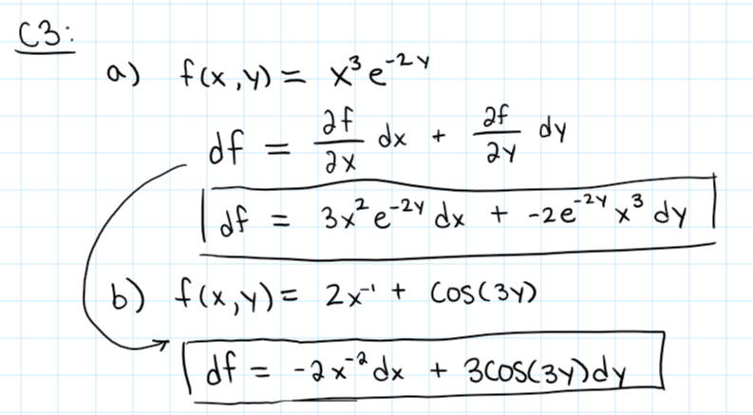

**C4:**

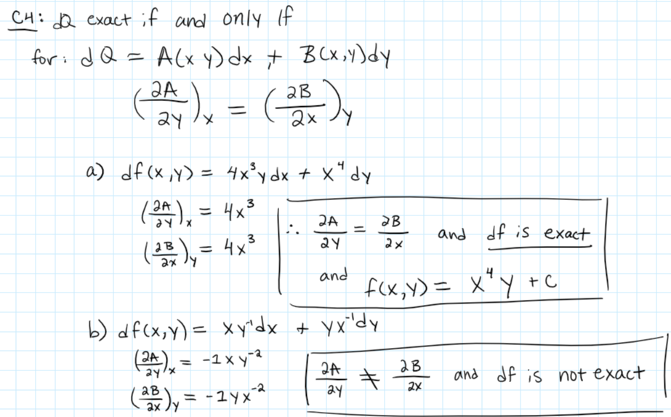

**C5:**

